**Brac University**

**CSE422: Artificial Intelligence**

**Question 1 (CO1)**

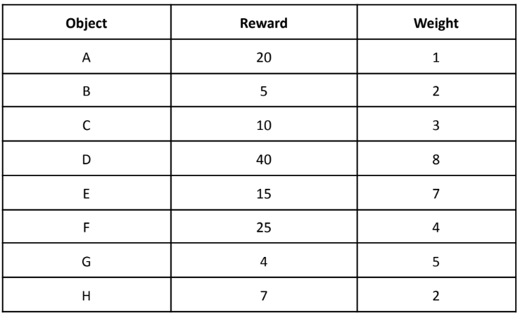

Maximum weight = 12

The above problem is a 0/1 Knapsack problem. You have to carry the different objects in your bag in a way such that the reward is maximized without exceeding the weight limit. You can carry an object exactly once but you always have to carry the object labeled “H”. Assuming you are asked to use Genetic Algorithm for this problem, answer the following questions

1. Encode the problem and create an initial population of 4 different chromosomes
2. Explain what would be an appropriate fitness function for this problem. Use the fitness function and perform natural selection to choose the 2 fittest chromosomes.
3. Using the selected chromosomes perform a single-point crossover to get 2 offspring.
4. Perform mutation and check the fitness of the final offspring. Explain your work.

**Question 2 (CO1)**

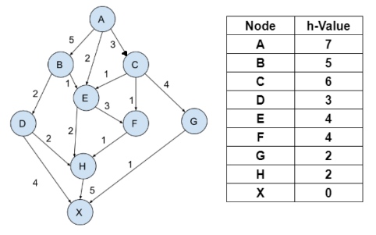

Apply Graph version of A* and Greedy Best First Search on the given graph to find the path and the cost of the path.

**Question 3 (CO1)**

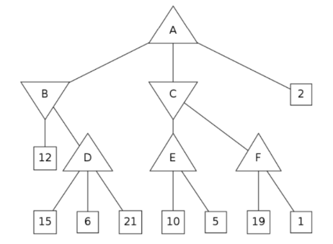

What will be the alpha- and beta- values of each node in this tree if alpha-beta pruning is run on this tree? Also, illustrate the crossed-out branches that would be pruned by alpha-beta pruning.

**Question 4 (CO1)**

Suppose you have an equation f(x) = x2 - 5x + 6. Assume x can be any number between 0 to 15. Now your job is to find an appropriate value of x such that the value of f(x) = 0 using Genetic Algorithm

1. Consider the fact that every chromosome will have 4 genes, illustrate an appropriate encoding technique to create an initial population of 4 randomly generated chromosomes.
2. Using an appropriate fitness function deduce the 2 fittest chromosomes and perform a single pointer crossover from the middle to create two offspring.
3. Explain how you can mutate the offspring derived from (B) and comment on the fitness of the final produced offspring.

**Question 5 (CO2)**

Explain the concept of forward checking with an example.

Suppose, the following graph represents a map coloring CSP problem. You are trying to color the following graph with 3 colors: Red, Green and Blue such that no two adjacent node has the same color. Node A is already colored as Red (R) and node G is colored as Green (G).

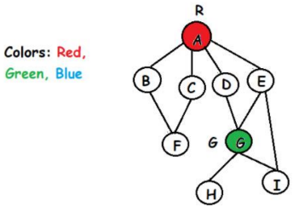

Assess which node will be visited in the following map coloring example if

1. Degree heuristic is used. Explain your answer.
2. According to Least constraining value heuristic, which color will be chosen for node B in the given graph? Explain your answer.